Instructions: MRI Rating Tool

Project Description
The simple MRI rating tool allows users to open MRI images and provide a numerical rating that describes the impact of artifact on the images quality.
The instructions below detail how to use this rating tool to assess MRI NIfTI files.

Requirements:
- ITK-SNAP (medical image viewing software)
  - http://www.itksnap.org/pmwiki/pmwiki.php?n=Downloads.SNAP3
- Python (latest stable version recommended)
  - https://www.python.org/downloads/

SECTION 1: FILE ORGANISATION
Ensure all necessary files are in the correct directory
For the MRI rating tool to run correctly the following items must be present in the same directory
- Python file containing the objects for the simpledb database management tool (simpledb_objects.py)
- Python file containing the functional rating tool script (mri_qa-marker.py)
- Directory of images in NIfTI file format

Step 1: Download python files (.py)
- Create a new directory (i.e. folder) to store files for the rating tool
- Download the following files and place them into the directory:
  - mri_qa-marker.py
  - simpledb_objects.py
Image: In the example below they have been moved into a directory named 'code'
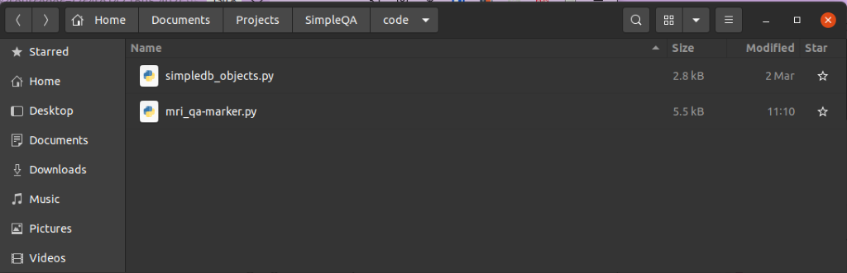

Step 2: Move NIfTI files into this directory
- Move the images (NIfTI files) into the directory containing the two python scripts
Note: the directory containing the images can have any name, the script will find any NIfTI (nii.gz) files contained in directory where the python scripts are stored
Image: In the example below a directory named ‘my_mri_images’ was moved into the directory
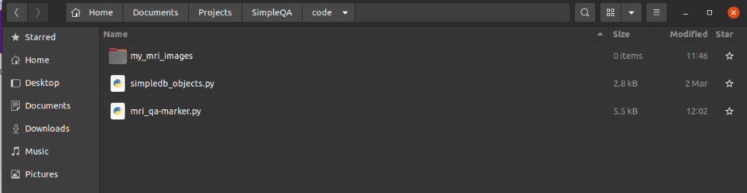

SECTION 2: RUN THE SCRIPT
To run the script you will need to have python installed, if you are unsure whether you have python installed simply follow step 1 below. If it is installed the script will run correctly, otherwise it will return the error: 'python: command not found' or 'python3: command not found'. For details about how to install python please see: https://www.python.org/downloads/

Step 1: Open a Terminal in the directory containing the python files and the MRI images
- Open a terminal and ensure you are in the directory containing the files
  - Example: <your_username_>:~/your/file/path/code$
  - In this example the terminal is open in the 'code' directory where the files are contained
- Execute the script by typing into the terminal and pressing enter:
  - python mri_qa-marker.py
Note: if you are using python version 3 you will need to type: python3 mri_qa-marker.py

Step 2: Choose your session
- You will be prompted to enter whether you would like to resume a previous review session or start a new one, indicate your choice by entering the corresponding number
Note: if you have not previously used the rating tool, a directory titled 'mri_rating_record' (see image below) will be generated, this is the output directory where your ratings will be stored as a .json file
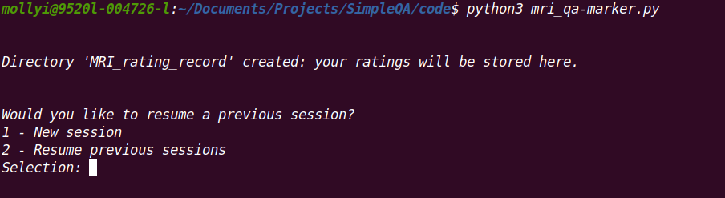
SECTION 3A: CHOOSING A NEW SESSION
Select a new session by entering '1'. This will bring up the ITK-SNAP window and your rating should be entered into the terminal.
Image: ITK-SNAP will open in a separate window (left), your rating should be entered in the terminal (right)
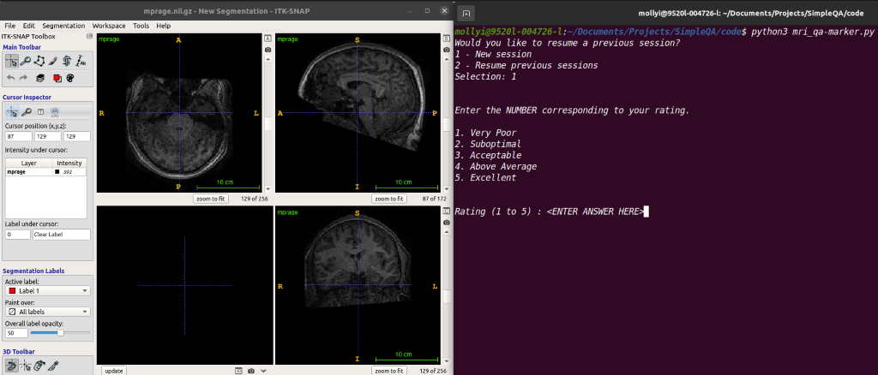

Step 1: Provide your rating
- Input your rating, a numerical rating between 1 and 5, into the terminal and press the 'Enter' key
- After pressing 'Enter' your rating will displayed back to you in the terminal (See image below)
- The current image will be closed and the next image for review will automatically be opened
- Continue through the images providing your rating in the terminal
Note: there is no need to close the ITK-SNAP window, it will close automatically when you provide your rating and the next image to be reviewed will be opened
Image: your rating will be displayed back to you in the terminal (‘Your rating was 4’)
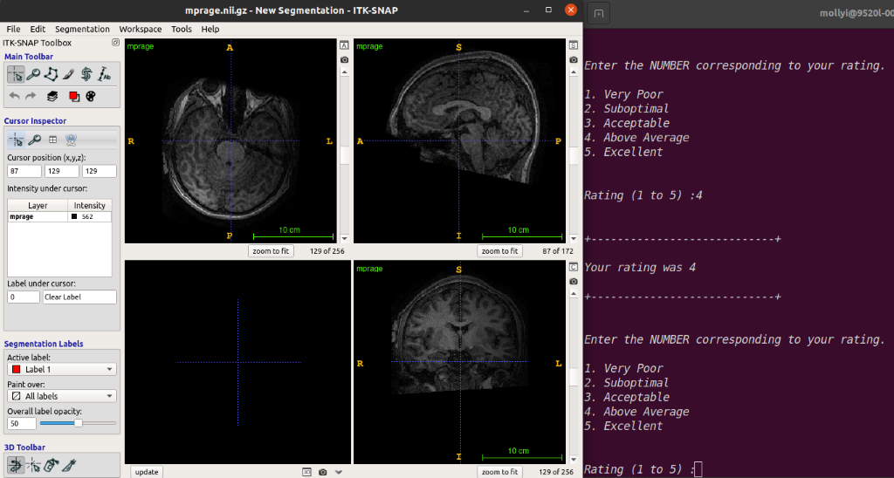

SECTION 3B: RESUMING A PREVIOUS SESSION
Resume reviewing a previous session by entering '2'. You will be prompted to select the session you wish to resume. The ITK-SNAP window will then only open images that have not yet been reviewed.

Step 1: Select your session
- Choose from the list of existing rating files by entering the corresponding number into the terminal
Image: There are 2 available sessions to resume ('MRIrate_session-25-03-2022_16:23:03' and 'MRIrate_session-25-03-2022_16:13:54')
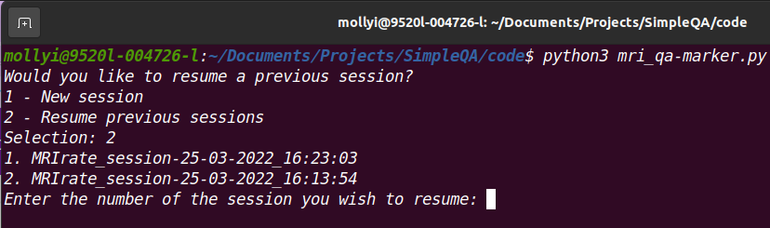
Step 2: Provide your rating
- After selecting the session to resume, the images that have been previously reviewed will appear in the terminal with the comment "file <file_name> has already been rated" (see image below)
- Once the script encounters an image file that has not yet been rated, you will be prompted to enter your rating and ITK-SNAP window containing the file will open
- Input your rating, a numerical rating between 1 and 5, into the terminal and press the 'Enter' key
- The previous image will be closed and the next image for review will automatically be opened
- Continue through the images providing your rating in the terminal
Note: there is no need to close the ITK-SNAP window, it will close automatically when you provide your rating and the next image to be reviewed will be opened
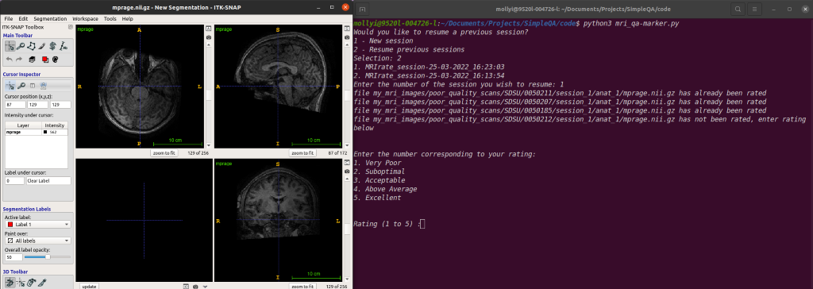

SECTION 4: ENDING YOUR SESSION
- There are 2 ways to end the session:
- Review all images in the directory
- Typing 'Ctrl' + 'C' in the terminal during a review session
Note: the files you review will be stored even if you terminate your session early
- In both cases the text '--END OF IMAGES--' will appear and you will be given an option to convert your review file to a .csv format (see image below)
  - If you select 'y' to convert the files, your .csv file can be found in the 'MRI_rating_record' directory with the accompanying .json file
Note: it is not necessary to make a .csv file to save your review, it is automatically saved as a .json file
Image: See example below where 'Ctrl' + 'C' was entered into the terminal to end the session
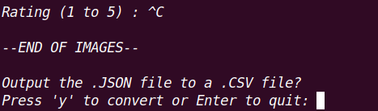
SECTION 5: ACCESSING YOUR REVIEW FILES
- All review files (.json, .csv) can be found in the directory 'MRI_rating_record' contained within the directory where the python scripts can be found

